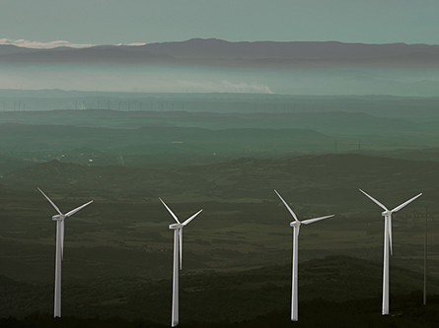

SCADA MAINTENANCE

The scope of all maintenance options proposed in this document is exclusively limited to the SCADA Server installed at the substation, and does not include, amongst others, the wind farm's remote equipment and internal communication lines

FULL SCADA MAINTENANCE

The scope of Siemens Gamesa proposed wind farm SCADA maintenance service is as follows:

  - Incident registration. Sending the SCADA template request to the SCADA support e-mail. The Siemens Gamesa technicians will provide a record of the incident and activate the analysis process by Siemens Gamesa support team. The response time will commence after the incident has been registered in our system and Siemens Gamesa immediately sends the subsequent confirmation e-mail to the client.

scada.support@siemensgamesa.com

  - Wind farm system manager support. Siemens Gamesa offers the client a telephone and e-mail support service through their define wind farm system manager to assist in SCADA doubts and provide quote if needed. This support is available during local working hours.

  - Continuous monitoring: Siemens Gamesa will monitor the wind farm and open an incident if necessary whenever permanent communications accesses to the SCADA are available.
- Monitoring that critical system services are active: SCADA, Regulators and Database.
- Hardware monitoring: Server, NAS, Routers, Switches, Power Supplies, and UPS.
- Monitoring of general system performance parameters: Temperatures, hard disk status and CPU performance.

  - Preventive maintenance: yearly remote and local preventive maintenance will be carried out per the scope of the tasks described in Annex A

  - Remote SCADA corrective maintenance during working hours.
    - Resolution of incidents derived exclusively of SCADA software that can be solved remotely, without on-site intervention at the wind farm by specialized personnel.
    - This includes correcting specific SCADA errors that will not need any software changes or update.
    - In addition, the Service Packs available for the installed SCADA version, which correct bugs, are also included.
    - Upgrading software to a newer version is not included.

  - Local SCADA Corrective Maintenance during working hours.

Costs derived of any corrective tasks required to repair the wind farm SCADA are covered, regardless of whether the problem concerns hardware or software (only when Siemens Gamesa has supplied the damaged equipment). This cost includes any necessary visits to the wind farm by specialized personnel. In case it is not possible to replace the Hardware of the current platform due to the product obsolescence, this HW will be quoted.
Siemens Gamesa will decide when an incident required a local resolution.

The maximum response time for responding to incidents will be 1 business day (Monday – Friday) from the e-mail notification of the same. This response time is the maximum period between when an incident is notified and a Siemens Gamesa contacts the client. This is no indication of resolution time.

FULL SCADA Maintenance Conditions

- External events or force majeure will release Siemens Gamesa from any liability for damages caused to SCADA HW (flooding, theft, overvoltage, vandalism, etc.) In such cases, the client must request Siemens Gamesa a quote for repair.

Annex a: Preventive Maintenance

The client must grant Siemens Gamesa access to the wind farm SCADA for performing any preventive maintenance remotely once a year.

Remote preventive maintenance tasks (yearly)
- Log compression and deletion
- Old backup compression and deletion
- Database maintenance
- System Unit Defragmentation
- Emptying temporary folders
- Antivirus check
- UPS battery inspection and maintenance. Ethernet UPS: Test Protocol
- Inspection and verification of the correct execution of automatic tasks run by the SCADA
- SW data backup
- Checking the correct operation of power and environmental regulation tools installed in the SCADA

A completed task report will be drafted and delivered

Local preventive maintenance tasks (yearly)
- Update to the latest Service Pack available for a given version of the SCADA & tools. Preparation [backup (SW+Data), data retrieval, deploying SW to the wind farm or preparing an image], programming, installation and corresponding checklist
- Check of the correct execution of the commuting of the redundant hardware.
- Rack cleaning
- Manual UPS battery inspection and maintenance. (Series or Ethernet UPS)
- Log compression and deletion
- Old backup compression and deletion
- Database maintenance
- System unit defragmentation
- Emptying temporary folders
- Antivirus check
- Inspection and verification of the correct execution of automatic tasks run by the SCADA
- SW data backup
- Checking the correct operation of power and environmental regulation tools installed in the SCADA

A completed task report will be drafted and delivered

